Jenkins Installation

**Step 1 : Install OpenJDK**

OpenJDK, the open-source implementation of the Java Platform, is the default Java development and runtime in CentOS 7. The installation is simple and straightforward.

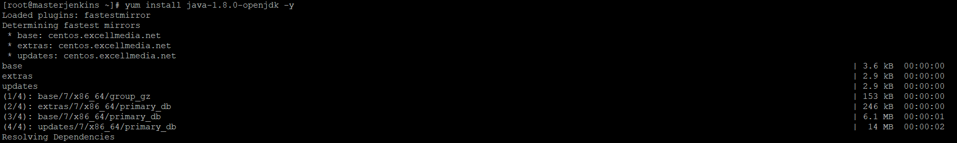

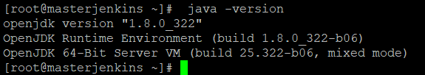

Configure Java Home Environment

[root@masterjenkins ~]# find /usr/lib/jvm/java-1.8* | head -n 3

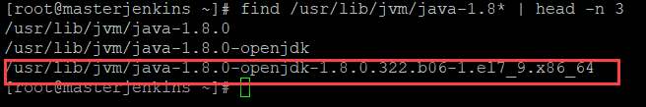

[root@masterjenkins ~]# JAVA_HOME=/usr/lib/jvm/java-1.8.0-openjdk-1.8.0.322.b06-1.el7_9.x86_64

[root@masterjenkins ~]# export JAVA_HOME

[root@masterjenkins ~]# PATH=$PATH:$JAVA_HOME

To set it permanently update your .bash_profile

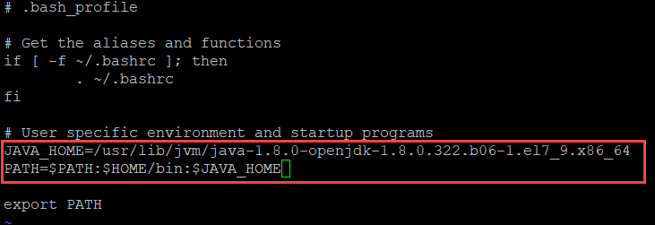

[root@masterjenkins ~]# source .bash_profile

[root@masterjenkins ~]# echo $JAVA_HOME

/usr/lib/jvm/java-1.8.0-openjdk-1.8.0.322.b06-1.el7_9.x86_64

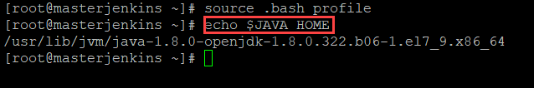

Step 2 : Install Jenkins

You can install jenkins using the rpm or by setting up the repo. We will set up the repo so that we can update it easily in the future.

Get the latest version of jenkins from https://pkg.jenkins.io/redhat-stable/ and install

yum -y install wget

wget -O /etc/yum.repos.d/jenkins.repo https://pkg.jenkins.io/redhat-stable/jenkins.repo

sudo rpm --import https://pkg.jenkins.io/redhat-stable/jenkins.io.key

yum -y install jenkins

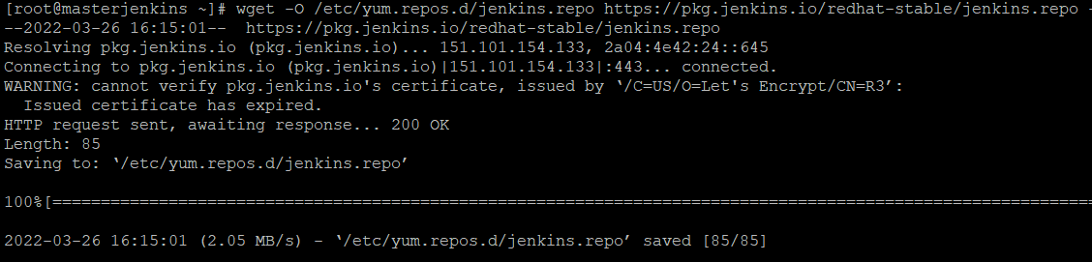

[root@masterjenkins ~]# rpm --import <https://pkg.jenkins.io/redhat-stable/jenkins.io.key>

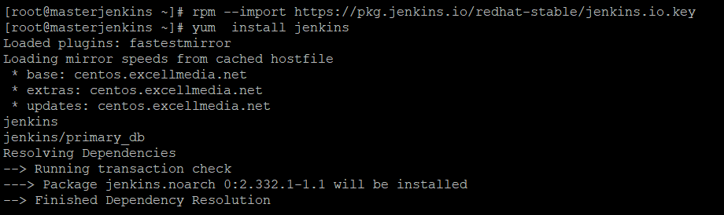

**Step 3: Start Jenkins**

# Start jenkins service

service jenkins start

# Setup Jenkins to start at boot,

chkconfig jenkins on



By default jenkins runs at port 8080, You can access jenkins at

[http://YOUR-SERVER-PUBLIC-IP:8080](http://your-server-public-ip:8080)

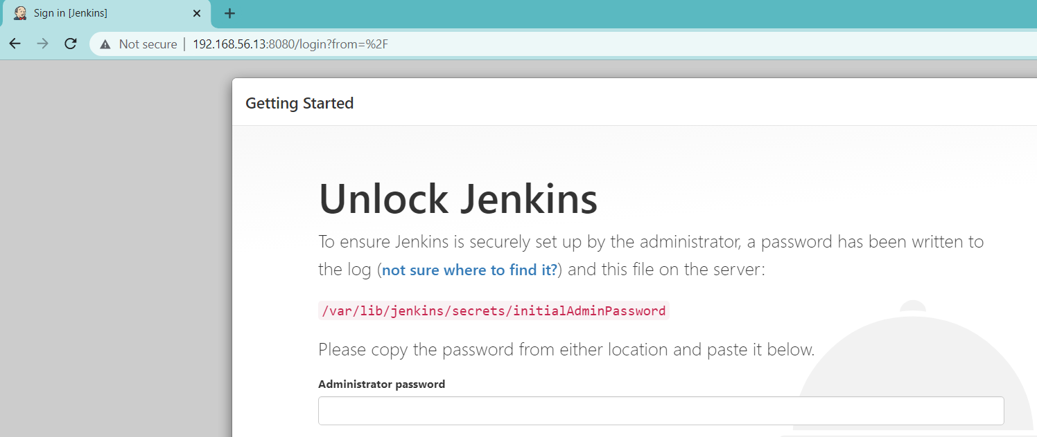

Get the password from the file : /var/lib/jenkins/secrets/initialAdminPassword



**Step 4: Install Nginx**

[root@masterjenkins ~]# yum -y install epel-release

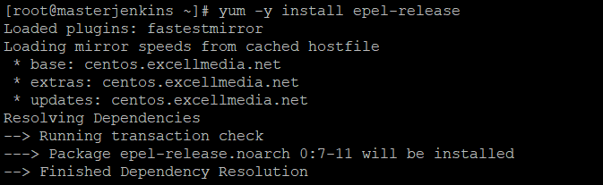

[root@masterjenkins ~]# yum -y install nginx

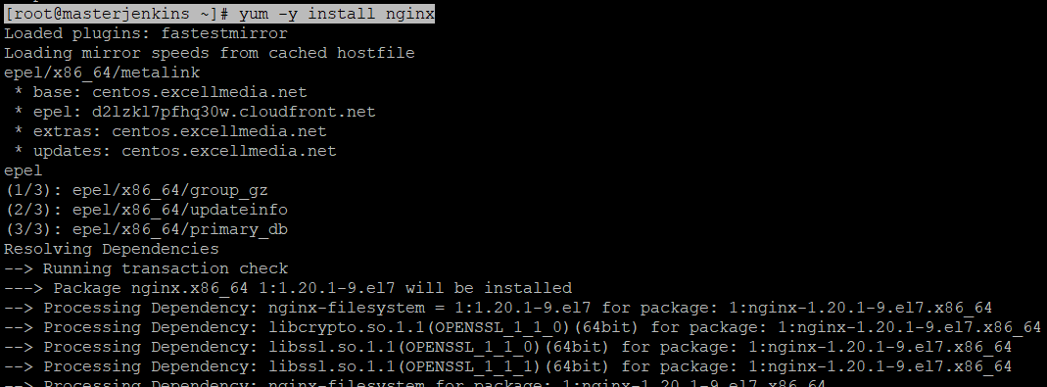

**Configure nginx**

**Create a file jenkins.conf under /etc/nginx/conf.d/**

**[root@masterjenkins ~]# cat /etc/nginx/conf.d/jenkins.conf**

**upstream jenkins{**

**server 127.0.0.1:8080;**

**}**

**server{**

**listen 80;**

**server_name abramdevops.jenkins.com;**

**access_log /var/log/nginx/jenkins.access.log;**

**error_log /var/log/nginx/jenkins.error.log;**

**proxy_buffers 16 64k;**

**proxy_buffer_size 128k;**

**location / {**

**proxy_pass http://jenkins;**

**proxy_next_upstream error timeout invalid_header http_500 http_502 http_503 http_504;**

**proxy_redirect off;**

**proxy_set_header Host $host;**

**proxy_set_header X-Real-IP $remote_addr;**

**proxy_set_header X-Forwarded-For $proxy_add_x_forwarded_for;**

**proxy_set_header X-Forwarded-Proto https;**

**}**

**}**

**[root@masterjenkins ~]#**

**[root@masterjenkins ~]# touch /var/log/nginx/jenkins.access.log**

**[root@masterjenkins ~]# touch /var/log/nginx/jenkins.error.log**

**[root@masterjenkins ~]# chown jenkins.jenkins -R /var/log/nginx/jenkins.access.log**

**[root@masterjenkins ~]# chown jenkins.jenkins -R /var/log/nginx/jenkins.error.log**

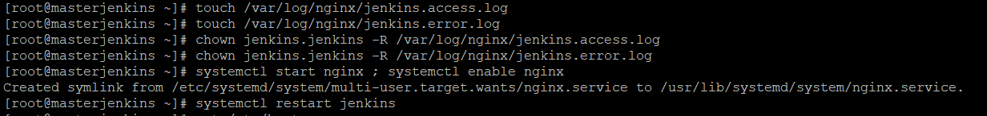

**[root@masterjenkins ~]# systemctl start nginx ; systemctl enable nginx**

**Created symlink from /etc/systemd/system/multi-user.target.wants/nginx.service to /usr/lib/systemd/system/nginx.service.**

**[root@masterjenkins ~]# systemctl restart jenkins**

**Modify the /etc/hosts file in windows and linux to access the jenkins url from browser**

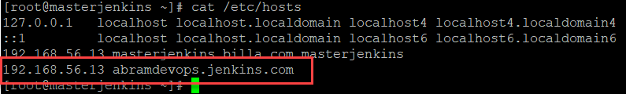

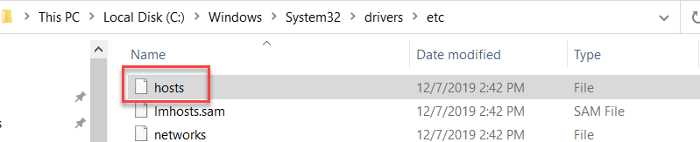

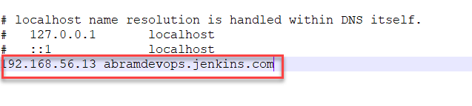

**Restart nginx and jenkins**

**[root@masterjenkins ~]# systemctl restart nginx && systemctl restart jenkins**

**[root@masterjenkins ~]# systemctl status nginx**

**[root@masterjenkins ~]# systemctl status jenkins**

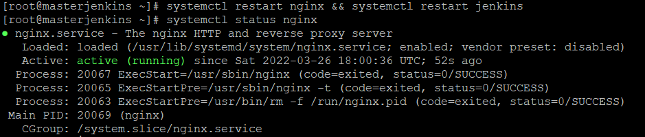

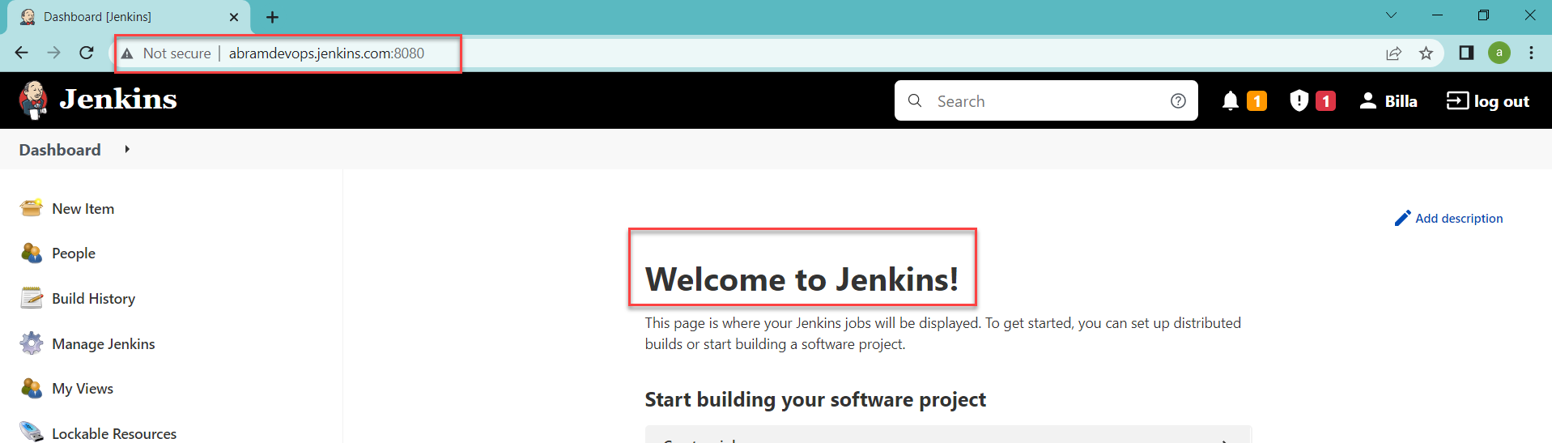

**That completes the jenkins installation with nginx**